**Gaussian Distribution**

It’s the most famous and important of all statistical distributions.Gaussian centered at 0 with a standard deviation of 1.

[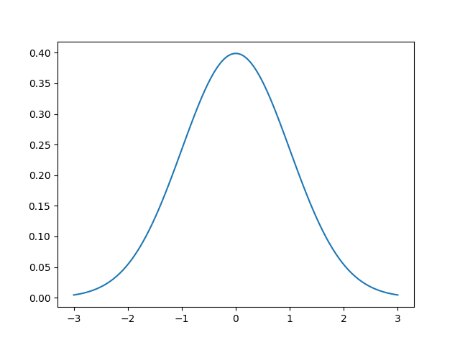](https://cdnpythonmachinelearning.azureedge.net/wp-content/uploads/2017/10/1D-Gaussian.png?x31195)

**-Chandrashekhar**

**Hadoop Trainer**

It is also called a **bell curve** sometimes.The function that describes the normal distribution is the following



so we’ll useto represent that equation. If we look at it, we notice there are one input and two parameters. First, let’s discuss the parameters and how they change the Gaussian. Then we can discuss what the input means.

The two parameters are called the**mean**  and **standard deviation** . In some cases, the standard deviation is replaced with the **variance** , which is just the square of the standard deviation.

The mean of the Gaussian simply shifts the center of the Gaussian, i.e. the “bump”or top of the bell. In the image above,, so the largest value is at.

The standard deviation is a measure of the*spread*of the Gaussian. It affects the “wideness” of the bell. Using a larger standard deviation means that the data are more spread out, rather than closer to the mean.

Technically, the above function is called the**probability density function (pdf)**and it tells us the probability of observing an input, given that specific normal distribution. But we’re only interested in the bell-curve properties of the Gaussian, not the fact that it represents a probability distribution.

#### **Gaussians in RBF nets**

We can use a*linear combination*of Gaussians to approximate any function!

